Chemistry Name ____________________________________
Reference Sheet – Reaction Rate Data

Directions: Here we have a table of experimental results concerning a reaction carried out at different concentrations. Determine the rate of change at each of the time intervals and series asked for below. NOTE: Limestone is Calcium Carbonate. The products contain water (l) and Carbon Dioxide (g).
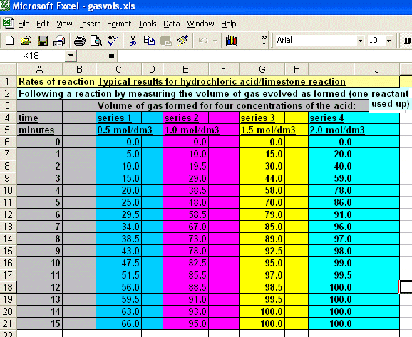
1. Write out the unbalanced equation __________________________________________

2. Write out the balanced equation __________________________________________

3. What is the rate of change of the CO₂ in the 4 series between 2 minutes and 4 minutes ?

____________ ____________ ____________ ____________
Series 1 Series 2 Series 3 Series 4

4. What is the rate of change of the CO₂ in the 4 series between 10 minutes and 12 minutes ?

____________ ____________ ____________ ____________
Series 1 Series 2 Series 3 Series 4

5. What is the rate of change of the H₂O in the 4 series between 10 minutes and 12 minutes ?

____________ ____________ ____________ ____________
Series 1 Series 2 Series 3 Series 4

6. What is the rate of change of the CaCO₃ in the 4 series between 10 minutes and 12 minutes ?

____________ ____________ ____________ ____________
Series 1 Series 2 Series 3 Series 4

7. What is the rate of change of the HCl in the 4 series between 10 minutes and 12 minutes ?

____________ ____________ ____________ ____________
Series 1 Series 2 Series 3 Series 4

